Regime Type and Armed Conflict in Africa

Samantha Kane Jiménez

Professor Seay

GO455: Conflict and Crisis in Africa

8 May 2020

Abstract

This paper examines the relationship between African states’ regime types and intrastate conflict onset, severity, duration and outcome. A robust body of literature on regime type and conflict focuses largely on global trends of a one-way directionality, using regime type to explain conflict. I expect a causal mechanism to operate in both directions between the two: civil wars can affect the kind of regime that emerges post-conflict and an African state’s regime type can influence the onset, severity, duration, and outcome of an internal conflict. I rely on logistic regression, multiple linear regression, and ordinary least squares regression models to test these associations, drawing on indicators from the Varieties of Democracy, Armed Conflict, and World Development Indicators datasets. The data indicate that more autocratic regimes experience more, longer, and more severe conflicts, but fewer relapses than democratic regimes; as well, longer conflicts are significantly associated with more autocratic regimes. These findings also suggest that the causal mechanism in question is stronger when regime type is used to predict conflict rather than in the opposite direction, in which really only conflict duration plays a significant role.

Table of Contents

Introduction 2

Literature Review 3

Regime Types and Conflict 4

Motives vs. Opportunities for Rebellion 4

State Capacity 5

Political Change and Conflict 6

Elections 7

Ethnic Fractionalization 8

Conflict in Democracies 9

Macroeconomics and Conflict 10

Lootable Resources 11

Miscellaneous Influences 12

Conflict in the Context of Africa 13

Methodology 14

Variables 14

Hypotheses and Statistical Models 14

Model 1: Conflict onset/continuation as a function of regime type in Africa 15

Model 2: Conflict severity as a function of regime type in Africa 15

Model 3: Conflict duration as a function of regime type in Africa 15

Model 4: Conflict relapse as a function of regime type in Africa 16

Model 5: Regime change as a function of conflict in Africa 16

Model 6: Regime type as a function of conflict in Africa 17

Datasets 17

Results 18

Conflict as a Function of Regime Type 18

Regimes as a Function of Conflict 22

Conclusion 22

Bibliography 24

Appendix 28

Introduction

This study examines the causal association between regime type and intrastate conflict in Africa. Uniquely, it focuses on two causal directions: I seek to identify both how different regime types affect armed conflict *and* how conflicts affect regime types. I seek to parse the dual mechanisms that connect the two elements to shed light on the subtleties of their relationship within the African context.

Throughout this paper, I use the term “regime type” to refer to the ordinal categorization of a political system on an authoritarian-democratic spectrum. Existing studies conceptualize regime types in various ways, with either minimalist or maximalist categorizations or continuous spectrums. The operationalization of regime type remains inconsistent across the field, and for the purposes of this study, I adhere to Lührmann, Lindberg and Tannenberg’s use of four ordinal definitions for polities, which allow for more assertive yet discerning analysis, particularly of the middling electoral regimes (known also as semi-democracies, anocracies, or hybrid regimes).[1] Per their definitions, closed autocracies (or full autocracies) do not hold elections and have no meaningful competition against the incumbent executive. Electoral (or competitive) autocracies hold multiparty elections without meeting full democratic standards; the electoral field is likely skewed toward the ruling faction and there may be de facto limitations on rights and freedoms. Electoral democracies hold de-facto free, fair, and competitive elections and have institutions to safeguard democratic values. Liberal democracies (or full democracies) are electoral democracies that uphold the rule of law, protect civil liberties, and promote horizontal and vertical accountability across the branches of government.

In terms of the second central element of this research, I consider four dimensions of conflict: its onset, severity, duration, and outcomes. Specifically, onset regards whether there is ongoing armed conflict, severity measures the intensity of the unrest based on casualty numbers, duration estimates the length of fighting, and outcomes identify whether there was a relapse of violence.

While there is extensive research investigating similar questions regarding the association between polities and unrest, this undertaking uniquely considers the duality of the causal mechanisms (as opposed to a singular causal direction). Most research along these lines tends to consider global patterns and regional deviations from those. Projects that analyze African patterns independently tend to hone in on varying aspects of a regime as the central explanatory variable –such as clientelism, ethnic fractionalization, or elections– rather than at the regime as a whole. Meanwhile, this paper focuses specifically on the African political stage while looking at conflict and regime type more broadly.

This under-studied quandary remains important. While understanding how political factors like elections and patronage systems affect conflict, bringing those elements together under the blanket of regime type might provide a helpful bird’s-eye view summary of the state of political violence in Africa over time. Such a panoramic, generalized understanding can inform important diplomatic and foreign policy decisions involving the Continent and its political leaders. Indeed, understanding the relationship between regime type and intrastate conflict can make international actors in Africa more aware of the potential repercussions of their political interactions in a state with a particular kind of regime. While the results might harden autocrats, prompting more repressive measures as a means of securing their hold on power, they might also help democracy-promoting actors to produce better-fitted assistance strategies for such tough cases, offering a wealth of information that can help foresee potential conflict catalysts and that can also help prevent the intensification, expansion, and relapse of violence. If foreign assistance actors are able to understand the dynamics of conflict within each type of regime, they might be able to drive aid and support programs with greater cognizance for safety and humanitarianism, reducing the number of unintended and unexpected potential negative consequences of a well-meaning assistance strategy. For instance, understanding a regime’s impact on the different dimensions of conflict may urge foreign assistance actors, such as aid agencies and non-governmental organizations (NGOs) to reconsider their strategies according to the regime type in place in order to mitigate conflict onset, severity, length, or relapse. As well, if certain conflict types tend to give way to particular regime types, foreign assistance programs may give greater priority to conflict prevention or more situationally apt conflict resolution. In short, having a better understanding of the association between these two elements serves to better explain the tradeoff between democratization and political conflict and can help produce potentially safer aid and assistance strategies depending on the type of regime.

Literature Review

The existing literature captures many elements that might destabilize peace. A wealth of research seeks to analyze the conditions that cause, lengthen, and intensify, and restoke conflict across the world. Yet, few works assess these four dimensions of conflict in concert, and even fewer focus the discipline to the African continent as a whole. Literature on African conflict tends to rely on individual states as the level of analysis unless researchers look at an individual condition’s effect on political violence. In other words, studies that consider the overarching, rather than specific, factors that influence intrastate violence across Africa elude the academic discipline that studies conflict and governance. Still, this work does not seek to dismantle previous research; instead, it seeks to rely on the rich academic substance that previous researchers put forth to inform a large-n, Africa-specific investigation of the multitude of governance factors that influence the onset, severity, duration, and outcome of intrastate conflict and the effects of those conflict dimensions on governance itself.

Regime Types and Conflict

An overwhelming amount of research finds an inverted-U shaped probability curve between regime type and conflict propensity and risk.[2] Controlling for GDP and socioeconomic factors, democracies are just as likely as autocracies are to experience civil war; these full regime types are significantly more stable than anocracies, which face much higher risks for conflict.[3] Hybrid regimes experience greater contention over the political system[4] and “simultaneous weaknesses of both democratic and repressive institutions” that keep dissent at bay in full regime types.[5] The repression anocracies do employ generates sufficient grievances for the public to seek avenues to air discontent, and the democratic institutions they do offer provide enough space to air dissent but not enough channels to effect change in line with those aired grievances.[6] Thus, insurgents can garner support outside of the political system and leverage it with violence; when the government fails to address the public’s grievances, weak security institutions provide an opportunity for rebellion.[7] Aware of these considerations, full autocracies unsurprisingly ensure post-conflict peace better than their hybrid counterparts.[8]

Motives vs. Opportunities for Rebellion

Fearon and Laitin laid the groundwork in examining motivations and opportunities for conflict as separate influences, finding, along with other scholars, that grievances are insufficient forces for prompting a civil war – there needs to be an alignment of opportunities.[9] Opportunities are the factors that allow for rebellion, and they relate to regime types in the sense that autocracies’ use of repression diminishes the opportunities to stage an insurgency; democracies allow an excess of opportunities to express discontent in a way that drowns out violence; and anocracies’ generally weak state capacity and economic performance indicate to an opposition the opportunity for a successful organized, violent dissent.[10] Rebels engage informal cost-benefit and game theory analyses to weigh their odds of success according to the circumstances their government offers. When insurgents estimate that a conflict will bring immediate payoffs or when they perceive a tactical superiority or potential to win, they experience greater motivation to fight (and such conflicts tend to last for longer periods of time).[11] As well, low per capita income is an opportunity for the rebels because it means the opportunity cost for joining their group remains low.[12] A group’s capacity to mobilize –based on its size, connections, and financial resources– enhances the likelihood of it taking up arms.[13]

Overall, where rebellion can happen, it will.[14] That is not to say, however, that grievances have null effects on conflict. Sufficient grievances can create an opportunity when the grievance outweighs the fear of repression: disenfranchised groups look to violent methods when they feel no other approach would be sufficient and see potentially promising benefits.[15] As well, grievances can enhance insurgencies once they do rise, for shared experiences of misery and discontent can help a group appeal to recruits.[16]

State Capacity

Not only do official institutions of governance play a role vis-à-vis conflict, but so do informal mechanisms, such as bureaucratic quality, respect for democratic values, modes of corruption, the role of the military in politics, political inclusion, and mutual toleration.[17] In fact, informal governance factors have a more significant, ameliorating effect on political violence than does the mere presence of strong state institutions. Strong state capacity reduces chance of conflict[18] while weak state capacity emboldens the opposition to keep fighting.[19] Autocrats extend their tenure through private payoffs of key political backers and security institutions,[20] and those who invest in state capacity better insulate themselves from uproar because weak institutional capacity reduces the state’s ability to suppress rebels, opening an opportunity on which the opposition can capitalize.[21] Anocracies tend to be in that latter situation, for they usually have weaker state capacity, contributing to their tenuous stability.[22]

Meanwhile, democracies succeed in preventing civil wars when they have strong state capacity in democratic and republican institutions.[23] Still, contributing to the fact that democracies in conflict experience longer wars, stronger state capacity can lengthen a conflict because effective institutions make it more difficult for rebels to progress toward victory.[24] Nonetheless, strong state capacity actually decreases a government’s overall odds of winning a civil war. Governments are more likely to win in the early stages of a conflict, whereas rebels are more likely to win as the conflict extends.

Political Change and Conflict

The democratization process increases the risk of civil war –particularly over governance rather than territory– which contributes to middling regimes’ instability.[25] Similarly, changes in political institutions and general political instability (such as irregular transitions of power) can also increase the risk of conflict.[26] For example, hybrid regimes in which elites gain control of institutions face greater odds for conflict.[27] Such systems benefit from transitional agreements that focus on short-term stability as a means to cultivating democratic institutions for the long term.[28]

At the same time, the mere threat of civil war can also prompt moves toward democracy.[29] Although political elites tend to stubbornly oppose democratization, for such a process would reduce their overall gains on power,[30] they take steps to avoid rebellion when it is imminent as an attempt to maintain their stature; sometimes that requires political liberalization as the most viable means to secure and maximize power in the future in a seemingly zero-sum game.[31] Still, democratic change takes a long time – civil war is more likely when opposition groups expect more immediate change or feel underrepresented by the nascent democratic institutions.[32] Such impatience and uncertainty in navigating political change incites a conflict trap, where failed improvements in governance after conflict push a state into subsequent episodes of political violence.[33] Yet, nonviolent resistance after a civil war can bolster peaceful democratization processes.[34]

Conflict traps can also exist independently of democratization. Mere political instability (without conflict) increases the risk for political violence within the subsequent three years.[35] Moreover, conflict is more likely where there was already conflict before.[36] Especially within the first five years after a conflict ends, the odds for relapse remain significantly high.[37] Reasons for such a susceptibility to relapse include fighting factions’ adherence to their war aims, regime inexperience, institutions’ novelty, and unresolved social tensions. Higher GDP per capita at the end of a conflict and post-conflict economic growth also reduce the odds for relapse.[38] Subsequent iterations of conflict do tend to be shorter than the original episode.[39] As well, the risk of relapse does fall over time.[40]

Overall, democratization casts a net negative effect on the prospects for peace, making an end goal of a democratic peace difficult to reach. Factors that exacerbate the barriers that democratization imposes include poor macroeconomic indicators,[41] competitive elections,[42] and large populations.[43] Thus, democratization is a laudable goal by itself, but not as a counterinsurgency or stability policy.[44]

Elections

Autocrats tend to respond to an imminent threat of civil war with elections.[45] Some scholars find significant associations between elections and the onset of conflict.[46] The question remains, however, whether elections as a last-ditch effort to prevent conflict merely precede a civil war or cause it: if the conflict the executive aimed to avoid was imminent, it would happen regardless of the election.[47] In Africa, more competitive elections tend to happen in this kind of situation, therefore are more likely to precede violence (but not necessarily cause it).[48]

Nonetheless, compelling evidence suggests that the political elite, trying to democratize while maintaining its hold on power, tries to align the people with their ethnic group, often inciting the marginalization of adversarial ethnic groups and stoking the risk for the onset of ethnic conflict.[49] Elections that lead to conflict tend to lead specifically to ethnic and territorial wars.[50] Indeed, Piccone contends that open electoral contestation where there is higher social fractionalization increases the odds for conflict. A sore loser phenomenon often turns to violence after competitive elections, especially in states where normative political behavior eschews democratic values, offering the losing group to call election results into question, often through violent means.[51]

Post-conflict elections tell a slightly different story. Initially, holding elections can reduce the odds of relapse; however, a year after the election takes place, the risk of relapse increases significantly relative to a baseline without elections.[52] More interestingly, a second set of elections especially increases the risk of relapse.[53]

Ethnic Fractionalization

Academics contest the role of ethnic fractionalization in conflict. Alesina, Devleeschauwer, Easterly, Kurlat, and Wacziarg lay the groundwork for this consideration, contending that greater fractionalization generates lower economic development prospects, perhaps because of its additional negative association with governance quality – which in turn can be connected to regime type.[54]

Particularly with relation to conflict, relative deprivation and higher centralization of power can increase the risk of conflict.[55] While some scholars suggest that social fractionalization significantly increases that prospect,[56] many more recognize that the mere marginalization of an ethnic group does not make it more likely to mount an insurgency; instead, ethnicity can serve as a crossroads of opportunity for rebellion, optimizing the opportunity to capitalize on their alignment.[57] Higher heterogeneity alone does not increase the odds of conflict: ethnic marginalization and heterogeneity can *motivate* rebel activity, but it does not capture the *opportunity* to rebel as well as favorable condition measures do.[58] Indeed, small groups can effectively mount a rebellion under the right circumstances, regardless of their level of targeted oppression, although they have a slimmer chance of winning a civil war against the government than do rebels in nonethnic conflicts.[59]

Still, the presence of larger and more numerous ethnic groups that are marginalized is associated with greater probability of ethnic conflict.[60] Collier, Hoeffler and Söderbom (2004) find that the optimal distribution of ethnic groups to maximize conflict odds and conflict duration is to have two or three prominent factions. Large ethnic groups, when excluded from power –which is scandalous relative to excluding smaller groups–, can count on their numbers to muster an army and rally against the government.[61] As well, ethnic appeals are usually easier to establish than other political allegiances and therefore stoking conflict on ethnic lines is more accessible.[62]

While higher ethnic inclusion reduces the risk of rebellion, it also increases the odds of a coup.[63] Coups from the ruler’s ethnic group are more likely when that ethnic group is the only one represented in the central government, meaning there are low levels of segmentation in the political system. Such intraethnic coups tend to be more successful than coups carried out by an incumbent’s former coconspirator, for leaders tend to purge their initial coalitions as a means to consolidating power.[64] Recently excluded coconspirator ethnic groups tend to launch violent rebellions more often than any other group but with lower success levels.[65]

Conflict in Democracies

While democratization risks bringing perilous circumstances, democracy generally reduces the risk of conflict.[66] Some researchers point to democratic values,[67] others to democratic institutions,[68] as the culprit for peace. The incidence of rebellion in democracies remains low, but when it does occur, insurgents rely on violent demonstrations because they expect less lethal government responses than they would in repressive autocratic regimes.[69] However, dissidents in democracies seldom resort to those violent means because inclusive governance increases the barriers to organizing a rebellion and offers formal channels of appeal through which discontent citizens can air their grievances.[70] As well, citizens who live in states that respect the rule of law, human rights, and civil and political liberties on average experience fewer overall grievances,[71] in turn reducing the motivating factors that contribute to conflict onset.[72] Conflicts that do occur in democracies tend to be over territory rather than governance,[73] and although they are longer, they are generally less lethal than conflicts in other polities.[74] Nonetheless, while democracy reduces conflict odds, conflict also reduces democracy (but not autocracy), leaving an unclear causal arrow between regime type and conflict experiences.[75]

Furthermore, existing literature points to an interaction effect between democracy and economic development. Income growth induces the development of market norms, which promote democratic values both in democracies and autocracies.[76] Overall, development both increases the odds for democratization and stabilizes democracies.[77] Yet, scholars agree that the effect of democracy on the risk of conflict predicates on economic development: democracy is better at insulating high-income states from conflict than it is for low-income states.[78] In other words, even though development is more insulating in democracies than in non-democracies, democratic institutions do not help reduce conflict risks where income is low: states must surpass a threshold of development to activate democracy’s conflict-reducing attributes.[79]

Macroeconomics and Conflict

In that same vein, the consensus that GDP per capita and economic growth and development are negatively associated with conflict[80] experiences growing nuance in its rationalization and interaction with particular situations. For instance, higher per capita income reduces the odds of nonethnic conflict onset[81] and the length of a conflict.[82] As well, higher income and prospects of economic growth in the decade succeeding a period of violence greatly reduce the odds of relapse[83] or of new conflict after non-violent regime change.[84] Favorable economic conditions also brace a state from plunging into civil war after it experiences regime change.[85]

There is greater contention over the effects of inequality on conflict. Some prominent voices argue that it negatively impacts the odds of maintaining peace;[86] indeed, secessionist conflicts are more likely to emerge in more economically deprived areas.[87] As well, greater inequality significantly lengthens conflicts that do break out.[88] Meanwhile, other groundbreakers in the discipline contend that inequality does not affect the prospects for civil war.[89] These latter voices indicate that inequality merely operates as a grievance in society, which is not enough to prompt violence; instead, they argue that conflict occurs where possible, based on opportunity rather than misery.

Separately, the economic liberalization process that often comes with greater economic development can also prove destabilizing for a regime. Low-income autocracies use private payoffs to keep the bare minimum support needed to stay in power and rely on repression to end unrest.[90] However, as the private sector expands, it can compete against the state sector, relatively devaluating the government’s ability to finance coercive outputs and reduce the government’s control and legitimacy, making it ripe for a coup or rebellion.[91]

Similarly, dependence on trade and capital can reduce unrest because unrest can risk driving away foreign direct investment and bring economic peril to the country; places with fewer capital-intensive economies face a higher risk of unrest.[92] At the same time, economic dependence on foreign powers largely determines development, growth, and inequality, which increases odds for conflict.[93]

Lootable Resources

Most research indicates that dependence on lootable resources increases the likelihood of conflict[94] – particularly over governance.[95] Indeed, the most severe conflicts occur within states that have a high primary commodity export (PCE) dependence,[96] although some scholars suggest that the authoritarianism associated with large PCE dependence, not the resource itself, is what associates with conflict proclivity.[97] Regardless, the availability of lootable resources helps rebels finance their programs[98] and allows rulers to finance patronage systems that sustain the executive’s political control.[99] As well, invested rents reduce conflict odds, while looted rents increase them.[100] More lootable resources are associated with greater odds of post-conflict rent distribution (which is especially attractive in winner-take-all political systems, which we often witness on the Continent) and therefore a greater incentive for political violence.[101] Wealth from natural resources also ensures the winning faction that the source of income will remain within the state after the conflict is over.[102] Where state assets are in the form of financial capital, the risk for redistribution is lower, and the prospect of political transition can be less threatening to political elites. It follows, then, that a drop in PCE prices reduces the length of a conflict, given that fighting factions see a reduction in cash flows to finance their activities.[103]

Miscellaneous Influences

Geography plays an interesting role in conflict, which deserves greater attention in research. Overall, larger states tend to be safer,[104] but larger populations tend to experience more and longer wars.[105] Particularly, larger proportions of young adult males increase conflict risk.[106] As well, regions with fewer states tend to experience less conflict than regions with more countries;[107] at the same time, government victories occur more often in states with many shared borders than in places with fewer neighbors.[108]

In terms of physical terrain, Buhaug and Rød contend that researchers should conduct territorial analysis at a geographic-grid level that erodes the state as the level of analysis. While they produce more nuanced results, state-level research also offers interesting and robust findings. Rough terrain favors rebel groups.[109] Particularly in Africa, sparsely wooded lowlands increase the risk of conflict.[110] Generally, mountainous regions decrease the likelihood of a government victory and increase odds of rebel victory or truce.[111] Forest cover usually extends a conflict, helps the government win, and decreases the odds of treaty outcome.[112]

Former colonizers also affect conflict today: former French colonies are less conflict-prone than other former colonies.[113] In part, this difference may occur because France is more willing to intervene militarily on behalf of its former colonies’ governments.[114] In contrast, foreign military interventions on behalf of rebel groups tend to reduce conflict length.[115] A United Nations intervention increases the odds of a conflict ending with a truce or treaty,[116] and the presence of and expenditures on post-conflict peacekeeping forces significantly reduce the odds of conflict relapse.[117]

Conflict in the Context of Africa

For the most part, existing literature focuses on global trends. Literature that examines African states more closely indicates that African wars tend to be longer and rebels are more likely to win relative to other regions.[118] As well, Africa experiences a similar incidence of conflict compared to other developing regions and global patterns between 1965 and 1999, but the structure of those risks differs.[119] Africa’s social composition insulates it from conflict, while its economic conditions bolster its risk for political violence. In Africa, opportunities to finance rebel groups, military viability (weak state capacity), histories of conflict relapse, and excessive grievances compound on one another to produce conflicts. Particularly, worsening economic trends at the turn of the century potentially caused an uptick in violence.

Notably, elections in Africa tend to decrease the risk of conflict, although that association changed over time.[120] After World War II, competitive elections increased conflict odds; during the Cold War, foreign power intervention potential also increased the odds of conflict onset and duration, particularly after elections; however, in the post-Cold War era, elections tend to decrease conflict risk. Specifically, when conflict does succeed elections, it is an independent result that would occur regardless of the electoral process, given autocrats’ use of elections as a last attempt to prevent civil war.[121]

African leaders more effectively extend their tenure by expanding their executive cabinets, which reduces the risk of coups.[122] However, cabinets larger than 31 ministers tend to increase the risk of rebellion. Leaders expand their cabinets to decrease their dependence on a single ally. States with more heterogeneous societies and larger populations also tend to have larger executive cabinets, which points to how leaders may use political appointments to fortify their patronage pyramids. Indeed, neopatrimonialism helps stabilize a regime, increasing the risk of democratic breakdown in democracies,[123] but perhaps also increasing the odds for democratization in non-democracies.[124] What prompts conflict, however, is not neopatrimonialism itself, but rather elites’ failures to follow through with their patronage promises.

Overall, the literature regarding regime type and conflict is dense; however, there is still a large amount of room to delve deeper into the substance matter. Particularly, my research will fill the gaps where several indicators for political violence are not synthesized across a large-n, particularly Africanist study in which they can interact to tell a fuller story that highlights the most prominent factors when they are all at play.

Methodology

Variables

This study investigates the association between conflict and regime type across fifty-three African states between 1960 and 2016 (with insufficient data across all pertinent variables for Cabo Verde, I dropped its cases from the dataset). I thus use country-years as the unit of observation, with each independent state pairing with each year in the dataset to create one of the 3,064 observations across 28 variables. The variables of utmost interest regard measures relating to regime type and conflict.

I operationalize the variable *regime_type* according to Lührmann et. al’s four ordinal categories, coding closed autocracies with 0; electoral autocracies, 1; electoral democracies, 2; and liberal democracies, 3. With regard to the dimensions of conflict, the variable *peace* is a binary measure for the presence of peace (coded 1) or the presence of internal armed conflict (coded 0) in a country-year. The variable *severity* is also an ordinal measure of a conflict’s intensity, coded 0 for no conflict, 1 for a minor conflict (with fewer than 1,000 battlefield deaths) and 2 for a war (with more than 1,000 battlefield deaths). *Duration* measures the number of years that a conflict spans. *Relapse* is an ordinal indicator for whether a conflict reignited after a period of pause, coded 0 for ongoing conflict years, 1 for a year of relapse, and 2 for no relapse.

Hypotheses and Statistical Models

The existing literature fails to conclude a singular causal direction between conflict and regime type in Africa. I predict that there is dual causality. I predict that each regime type is likely to experience conflict in different ways; likewise, the outcome of a conflict must be different across polities. Relying on 3,064 observations and 16 variables, I produce two sets of models: the first aims to explain four dimensions of conflict based on regime type and the second aims to do so for regime type and polity changes based on conflict indicators. For the conflict models, I create two variants for each: one relies on the continuous measure of regime type to see the overall patterns, while the other presents categorized slopes for each type of regime. All models control for inequality, neopatrimonialism, political instability, population, and time. Extensive missing data for the PCE and GDP-related control variables impeded their inclusion in the full models. I ran separate models to control for GDP indicators and PCE with available cases, finding no significant differences between these and their full-case counterparts.

Model 1: Conflict onset/continuation as a function of regime type in Africa

Given the inverted-U-shape probability curve for conflict onset relative to regime type, I hypothesize the following:

H1a: Closed autocracies decrease the odds of conflict onset.

H1b: Electoral autocracies increase the odds of conflict onset.

H1c: Electoral democracies increase the odds of conflict onset.

H1d: Liberal democracies decrease the odds of conflict onset.

I test this first set of hypotheses with Model 1, which logistically regresses the binary *peace* variable on *regime_type* and controls:

Model 2: Conflict severity as a function of regime type in Africa

As well, taking into account regime’s varying willingness to enlist violent means of repression, I predict:

H2a: Closed autocracies increase the severity of conflict.

H2b: Electoral autocracies largely increase the severity of conflict.

H2c: Electoral democracies moderately increase the severity of conflict.

H2d: Liberal democracies decrease the severity of conflict.

Model 2 is an ordinal least squares regression, used to test this set of hypotheses:

Model 3: Conflict duration as a function of regime type in Africa

Along those lines, I anticipate that closed autocracies’ broader reliance on repression will produce shorter conflicts, whereas democratic governments’ aversion to violence lengthens conflicts. For middling regimes, I anticipate that weak state capacity extends their armed conflict. In short:

H3a: Closed autocracies decrease the duration of conflict.

H3b: Electoral autocracies increase the duration of conflict.

H3c: Electoral democracies increase the duration of conflict.

H3d: Liberal democracies increase the duration of conflict.

Model 3 is a multiple linear regression that tests this set of hypotheses:

Model 4: Conflict relapse as a function of regime type in Africa

I foresee similar mechanisms influencing conflict relapse, with weak state capacity in hybrid regimes increasing the odds of restoking violence and autocracies’ use of repression and democracies’ tenets of compromise and negotiation reducing relapse odds. In other words:

H4a: Closed autocracies decrease the risk of conflict relapse.

H4b: Electoral autocracies increase the risk of conflict relapse.

H4c: Electoral democracies increase the risk of conflict relapse.

H4d: Liberal democracies decrease the risk of conflict relapse.

Model 4 uses an ordinal least squares regression to test this set of hypotheses:

Model 5: Regime change as a function of conflict in Africa

Regarding the opposite causal linkage, I expect conflict to affect regime type as follows:

H5: Conflict increases the likelihood of regime change.

H6: Conflict in autocracies increases the likelihood of democratization.

H7: Conflict in democracies increases the likelihood of democratic breakdown.

H8: Conflict in democracies increases the likelihood of democratic backsliding.

Model 5 is a multiple linear regression model to tests hypotheses five through eight:

Model 6: Regime type as a function of conflict in Africa

Aside from predicted changes in regime type based on conflict indicators, I expect that conflict negatively affects the type of regime. In other words, I expect a greater, overlap between conflict and autocratic regimes than conflict and democratic regimes. To summarize:

H9: There is a positive association between regime type and peace.

H10: There is a negative association between regime type and conflict severity.

H11: There is a negative association between regime type and conflict duration.

H12: There is a negative association between regime type and conflict relapse.

Model 6 is a multiple linear regression to test the above predictions:

Datasets

I create the African Conflict Dataset based on four existing datasets. The ninth version of the Varieties of Democracy provides most of the governance indicators.[125] Particularly, Lührmann, Lindberg and Tannenberg’s contribution to the dataset with their Regimes of the World measure defines regime type – one of the central variables in this study.[126] With similar prominence, the Armed Conflict Database supplies important conflict information on which this study hinges: it brings forth historical records of conflict since 1946, including where and when a conflict happened, how long it lasted, and whether there were intermittent periods of peace.[127] From this information I am able to identify the response variables for the first part of the study. I use the World Development Indicators[128] database to obtain macroeconomic control measures that resonate with important notions from the existing literature.

My dataset merges variables from the aforementioned sources and subsets world data to the African continent. As well, in this data frame, I create a handful of helpful variables. Honing in on conflict conditions, I create a *duration* variable that measures the number of years between the start and end of a conflict. I also expand the *peace* variable to country-years not featured in the Armed Conflict Database; thus, a measure of whether conflict is ongoing is available for every observation. As well, I provide the *lastconfyear* variable, which indicates for every country-year the year in which a given country experienced armed conflict. From *lastconfyear* I produce a *recency* variable, which measures the number of years between an observation and the last year with armed conflict. Furthermore, I yield a *relapse* indicator, coded 0 for ongoing conflict, 1 for country-years that return to armed conflict after a period of reprieve, and 2 for post-conflict country-years that do not experience a relapse into armed conflict. Lastly, I gauge annual changes in the *regime_type_amb* variable –which accounts for a regime’s ambiguous stance within one of Lührmann et. al’s categorizations– to assemble a *regime_changed* measure, where positive values indicate that a state changed toward democratization from the previous year to the year of observation, and negative values point to democratic backsliding. This variable is continuous on a scale of -9 to 9, and larger absolute values demarcate a larger degree of change. Similarly, I constructed a *regime_will_change* variable, which operates in the same fashion, but compares a year of observation with the following year. This lead version of *regime_change* serves to distinguish whether events in the year of observation contributed to or resulted from a change in regime.

Results

Conflict as a Function of Regime Type

Table 1 summarizes the regression outputs explaining the dimensions of conflict. Most predictors –including control variables– in Models 1 through 4 provide significant results. Despite the large number of significant terms, I regard their roles as legitimate based on their prominence throughout a series of exploratory models, in which overall statistical significance patterns remained somewhat constant, with individual predictors’ significance changing depending on the controls included in each of the explorations. Examples of such changes are available in the Appendix. Indeed, each statistically significant indicator contributes meaningful information to the model that other variables do not already take into account.

In each model, at least one iteration of the regime type variable significantly contributes to conflict. The continuous regime type measure is significant in every A-model: it is positively associated with peace and relapse and negatively associated with severity and duration. At least one regime type category in each of the B-models is significantly associated with the respective conflict dimension.

Figure 1 displays the continuous effects of regime type on peace, which are significantly positive. Yet, relative to the baseline of closed autocracies, only electoral democracies significantly increase the odds for peace, which counters Hypothesis 1c. With insufficient evidence for Hypotheses 1a, b, and d, I reject the entire first set of predictions.

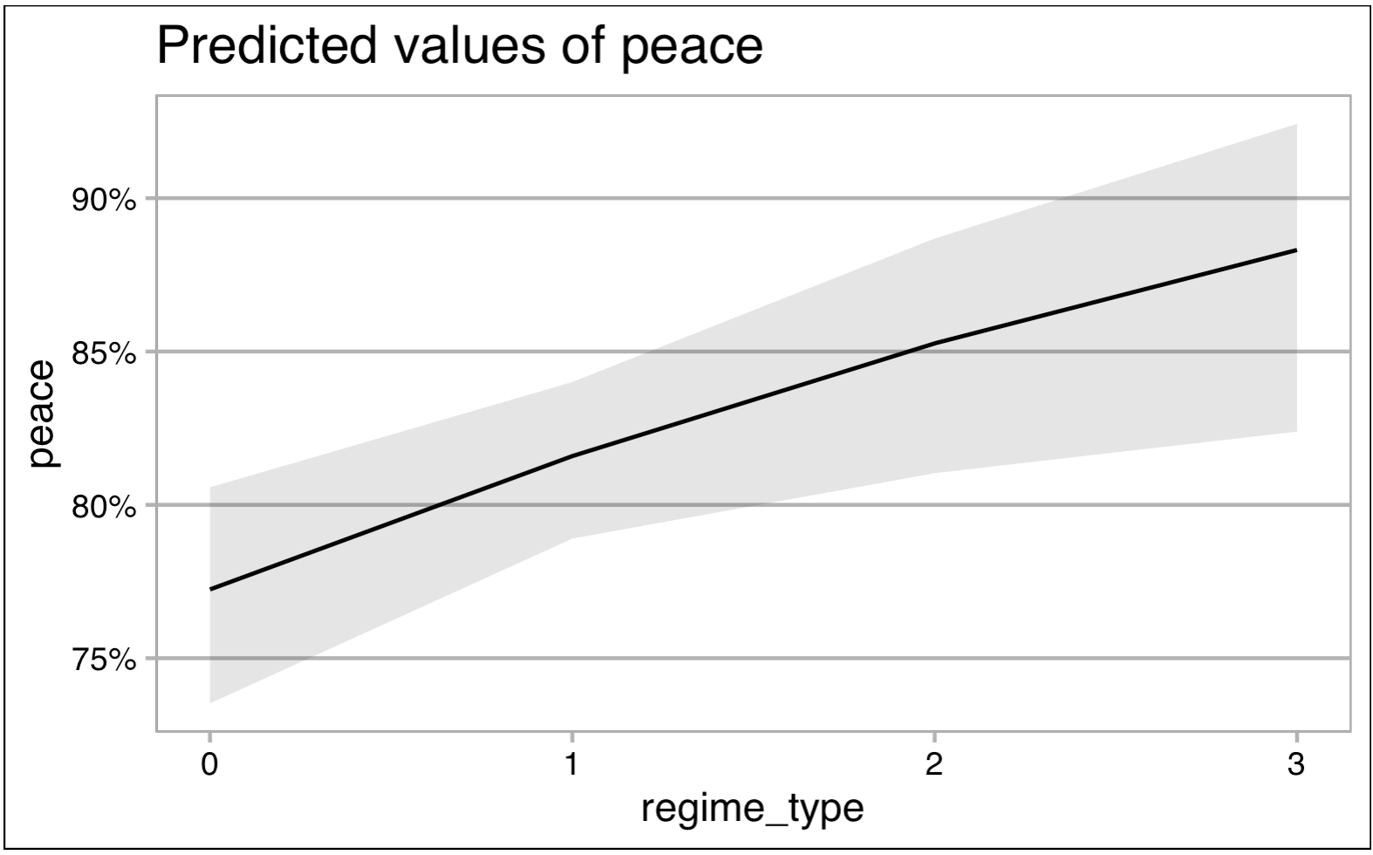

Figure 2. Predicted effects of a continuous regime type measure on peace based on Model 1a.

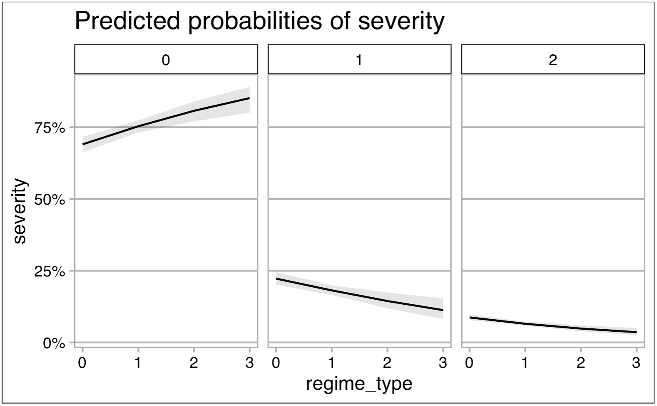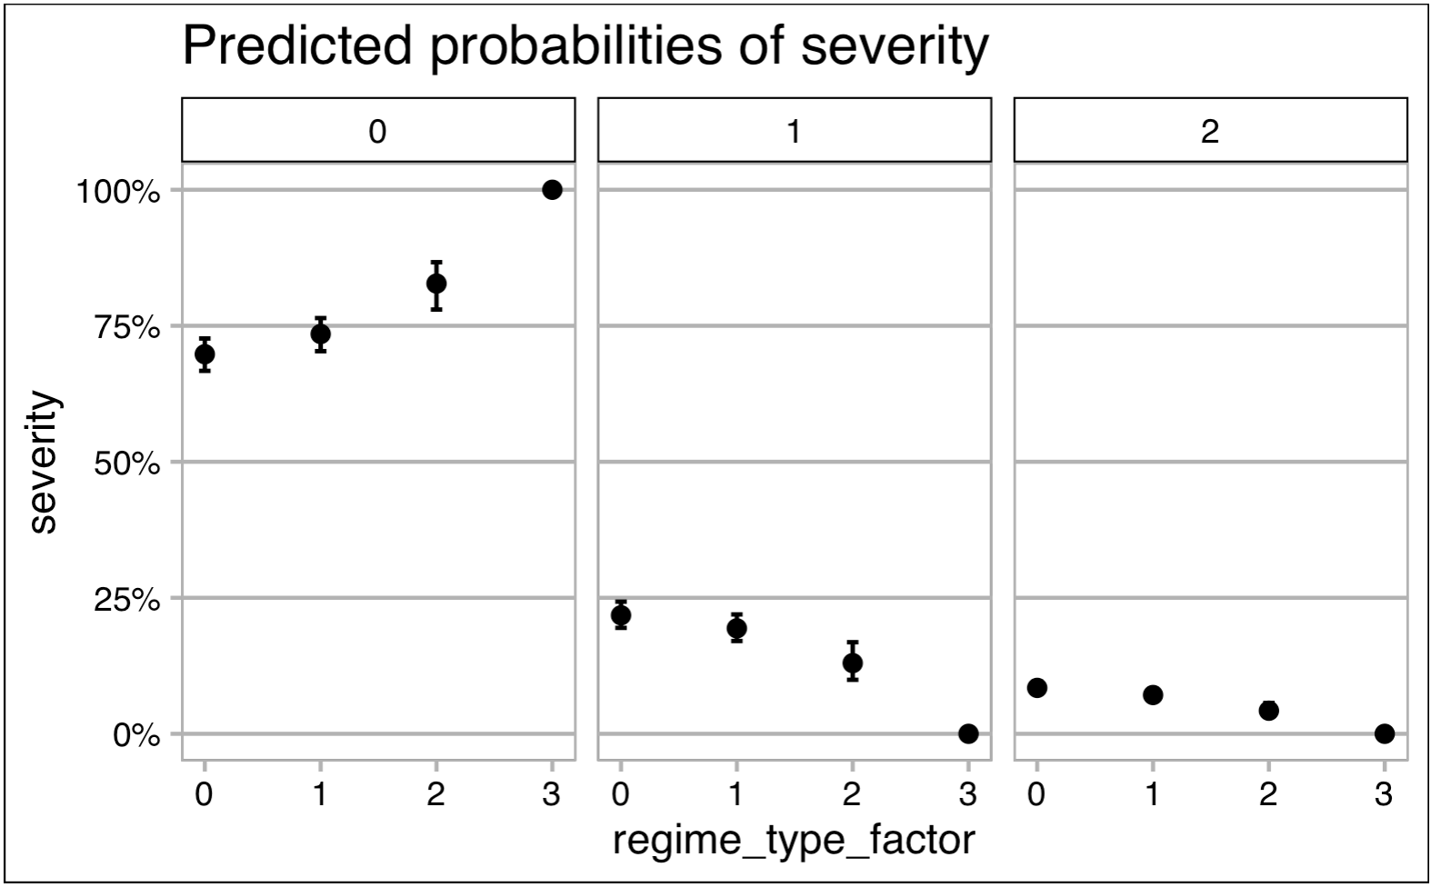

Figure 2. Predicted effects of a continuous regime type measure on conflict severity based on Model 2a.

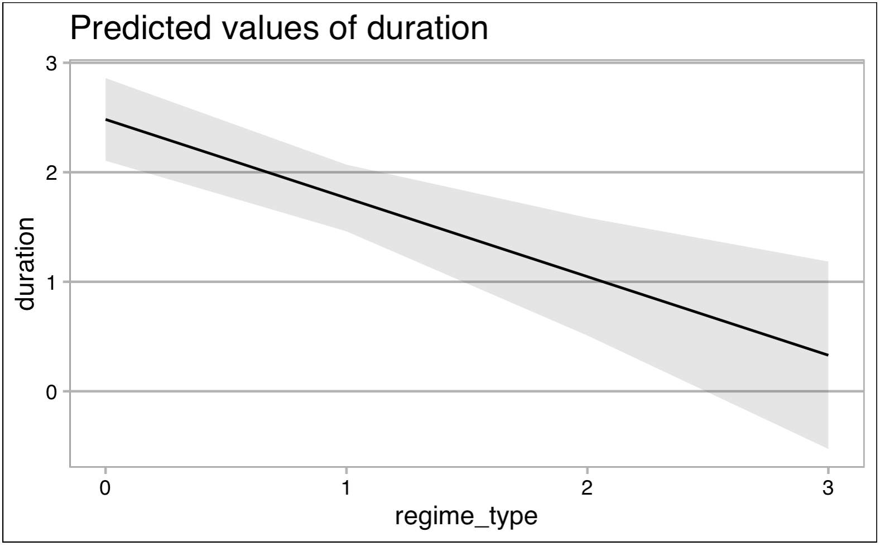

Figure 2. Predicted effects of regime type by category on conflict severity based on Model 2b.

Figure 4. Predicted effects of a continuous regime type measure on conflict duration based on Model 3a.

I also reject the second set of hypotheses based on the significant results from Model 2b, shown in Figure 3. Each degree of separation between a regime and the closed autocracy baseline magnifies a regime’s negative effects on severity, as Figure 2 helps visualize. While all non-closed autocratic regime types have a negative association with severity, the effect of electoral autocracies is not as strong as that of electoral democracies (countering Hypotheses 2b and c); the effect of electoral democracies in turn is not nearly as strong as that of liberal democracies (providing evidence against Hypothesis 2d).

Similarly, the results dismantle the third set of hypotheses, which regards conflict duration. Despite the literature’s stipulations that democracies tend to extend conflicts, the results suggest the opposite: all regime types, relative to closed autocracies, significantly reduce conflict duration, effectively offering evidence against Hypotheses 3a-d. Figures 4 and 5 visualize these effects. Additionally, conflict relapse is significantly more likely among democratic regimes –both electoral and liberal– as Figures 6 and 7 depict. This evidence supports Hypothesis 4c but opposes Hypothesis 4d. Negligible effects of closed and electoral autocracies on conflict relapse also lead me to reject Hypotheses 4a and b.

Overall, assessing the role of regime types on conflict dimensions provides evidence that counters all but one hypothesis: Hypothesis 4c. Nonetheless, the wealth of significant indicators remains promising and also points to influential control measures. Compelling control variables include resource and power inequality and clientelism, which significantly increase the odds of peace but also of relapse, while contributing to the decrease of conflict severity and duration. In the opposite direction, yet equally convincing, presidentialism is negatively associated with peace, extends and intensifies conflicts, and increases the odds of relapse. Similarly, over time, conflicts are more likely, more severe, longer, and likelier to reignite after a period of peace. As well, while coups increase conflict and relapse odds and intensify armed conflict, they tend to shorten episodes of unrest.

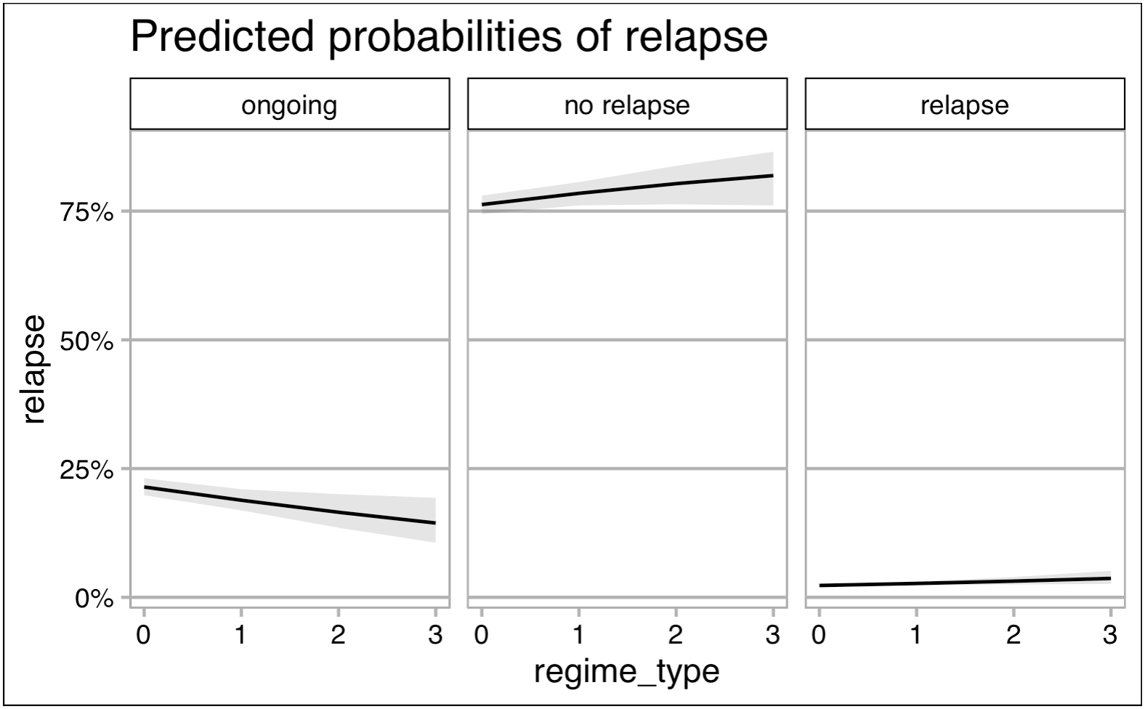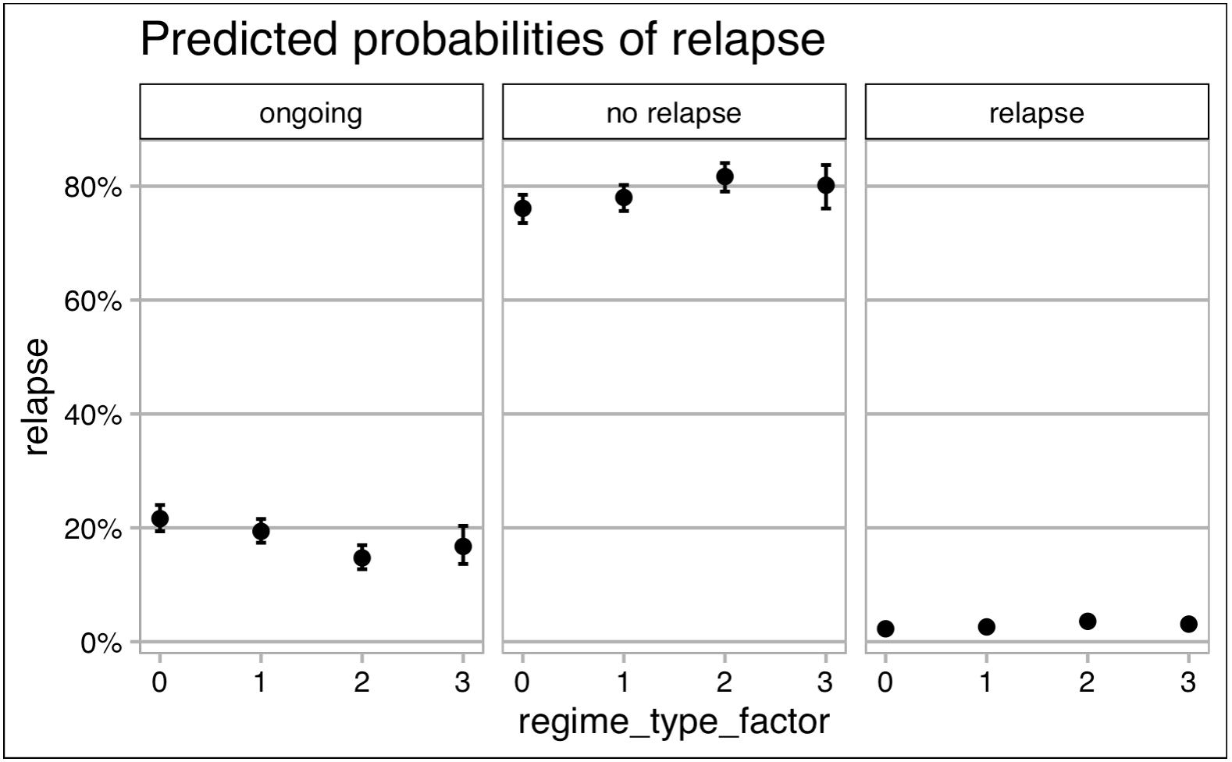

Figure 6. Predicted effects of a continuous regime type measure on conflict relapse based on Model 4a.

Figure 7. Predicted effects of regime type by category on conflict relapse based on Model 4b.

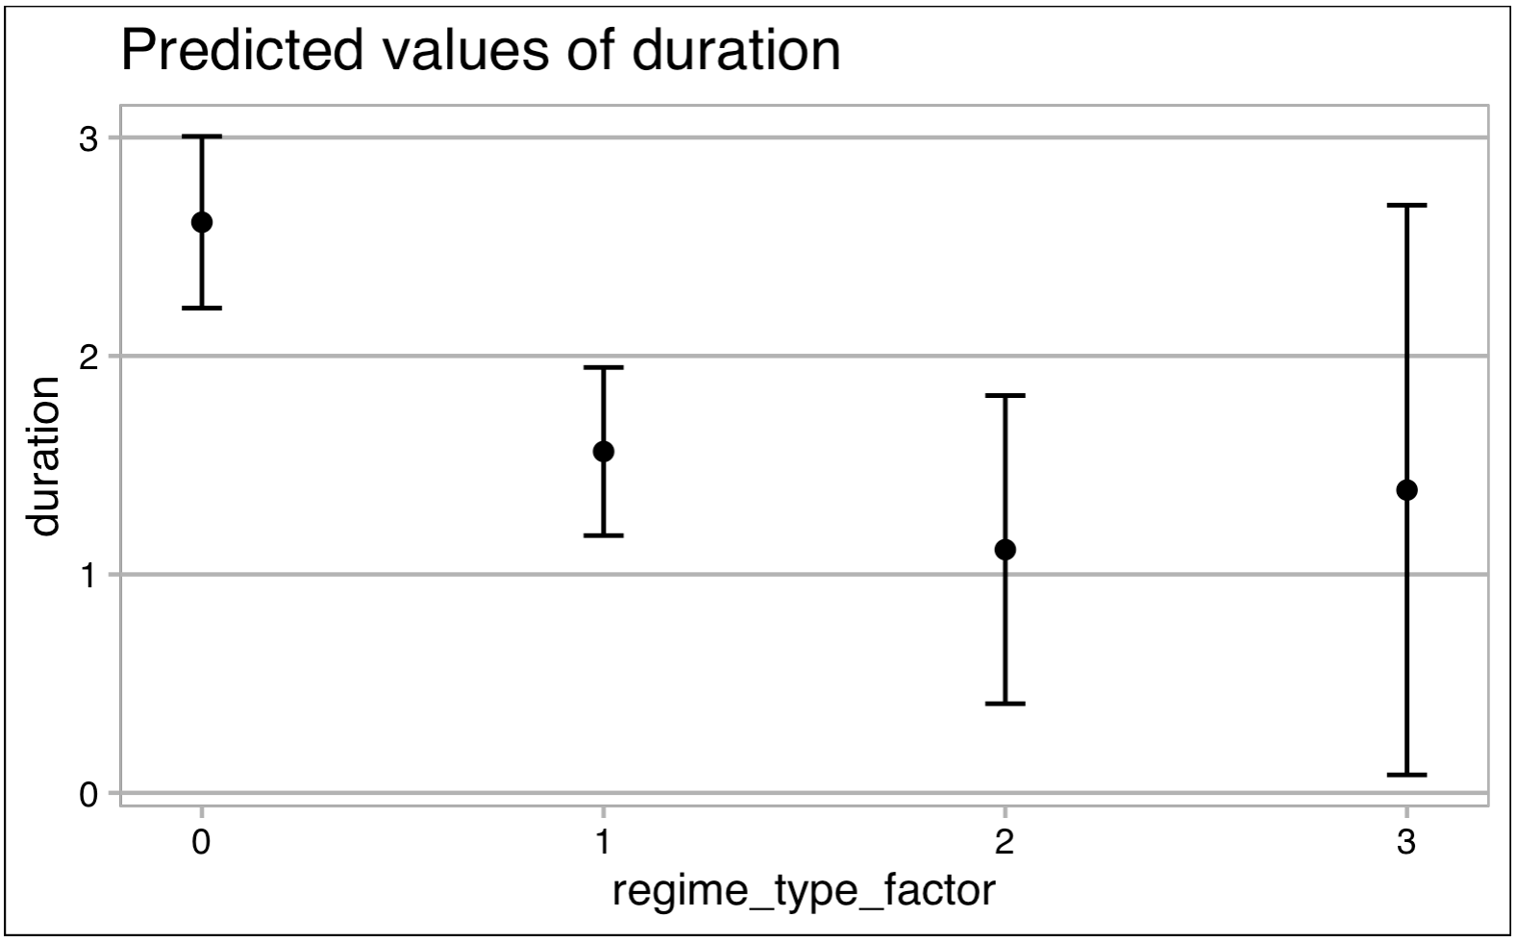

Figure 5. Predicted effects of regime type by category on conflict duration based on Model 3b.

Surprisingly, regime change plays a significant, negative role only with regard to conflict duration, and only when gauged alongside a continuous operationalization of regime type (Model 3a). The proportion of fighting-aged males and population size also have ambiguous effects across the first set of models.

About half of the total cases lack PCE data, and 189 cases lack GDP data. Nonetheless, I run models with these components and include their regression summaries in the Appendix. Models that control for PCE eliminate the impact of regime type on conflict duration and relapse. Controlling for GDP does not change the effects of the central explanatory variables in any of the models. Full models –with both PCE and GDP controls– resemble the significant associations that the original models that I include in this section elucidate.

|  |  |  |  |  |  |  |  |  |
| --- | --- | --- | --- | --- | --- | --- | --- | --- |
|  | **Conflict Dimensions** | | | | | | | |
|  | Peace | | Severity | | Duration | | Relapse | |
|  | Continuous  (1a) | Ordinal  (1b) | Continuous  (2a) | Ordinal  (2b) | Continuous  (3a) | Ordinal  (3b) | Continuous  (4a) | Ordinal  (4b) |
| Regime Type: cont. | 0.267 ** |  | -0.315 *** |  | -0.050 *** |  | 0.160 ** |  |
| Regime Type: Electoral Autocracy |  | 0.136 |  | -0.183† |  | -1.050 *** |  | 0.137 |
| Regime Type: Electoral Democracy |  | 0.563 * |  | -0.732 *** |  | -1.499 *** |  | 0.469 *** |
| Regime Type: Liberal Democracy |  | 14.280 |  | -14.277 *** |  | -1.224 † |  | 0.316 *** |
| Regime Changed | -0.031 | -0.020 | 0.028 | 0.018 | -0.718 *** | 0.125 | 0.032 | 0.030 |
| Resource Inequality2 | 2.276 *** | 2.252 *** | -3.299 *** | -3.225 *** | -2.102 | -2.243 *** | 1.605 *** | 1.664 *** |
| Power Inequality | 1.143 *** | 1.154 *** | -0.910 *** | -0.910 *** | -2.266 *** | -2.073 *** | 1.099 *** | 1.039 *** |
| Clientelism | 2.326 | 2.409 *** | -2.336 *** | -2.390 *** | -7.500 *** | -7.307 *** | 2.749 *** | 2.744 *** |
| Presidentialism | -2.666 *** | -2.551 *** | 2.315 *** | 2.184 *** | 6.172 *** | 6.383 *** | -2.190 *** | -2.152 *** |
| Coup | -0.461 *** | -0.453 *** | 0.428 *** | 0.418 *** | -0.007 | -0.005 | 0.104 | 0.110 |
| Population | -2.818e-08 *** | -2.806e-08 *** |  |  | 6.405e-08 *** | 6.494e-08 *** |  |  |
| Males 15-29 as % of population | -0.194 ** | 0.188 ** | -0.184 ** | -0.182 ** | -0.307 ** | -0.310 ** | 0.104 | 0.107 |
| Year | -0.004 *** | -0.038 *** | 0.047 *** | 0.047 *** | 0.079 *** | 0.079 *** | -0.034 | -0.035 |
| *Significance Notation:* | *p<0.0001 ‘***’; p<0.001 ‘**’; p<0.01 ‘*’; p<0.5 ‘†’* | | | | | | | |

**Table 1. Models 1-4, showing the four dimensions of conflict regressed on regime type –both continuous and ordinal– and control variables.**

|  |  |  |
| --- | --- | --- |
|  | **Regime** | |
|  | Change  (5) | Type  (6) |
| Peace: Yes | -0.030 | -0.942 |
| Severity: Minor conflict | -0.045 | -0.821 |
| Severity: War | 0.046 | 0.239 |
| Duration | 0.000 | -0.020 ** |
| Relapse: No | NA | NA |
| Relapse: Yes | -0.076 | -0.106 |
| Resource Inequality2 | -0.059 | 0.445 * |
| Power Inequality | 0.087 | 0.633 *** |
| Clientelism | -0.038 | -0.715 *** |
| Presidentialism | 0.010 | -4.241 *** |
| Coup | -0.157 *** | -0.306 *** |
| Population | 0.000 | 0.000 |
| Males 15-29 as % of population | -0.007 | 0.115 *** |
| Year | 0.001 | 0.045 *** |
| *Significance Notation:* | *p<0.0001 ‘***’; p<0.001 ‘**’; p<0.01 ‘*’* | |
| Table 2. Model 5, showing regime change regressed on the four dimensions of conflict and control variables. | | |

Regimes as a Function of Conflict

Table 2 summarizes the results from Models 5 and 6. With regard to regime type, Model 5 suggests that there is no change in leadership style based on any of the four conflict dimensions. Indeed, the only significant negative prompt for regime change is coup attempts. However, in terms of regime type, conflict does seem to play a significant role in at least one regard: shorter conflicts are significantly associated with more democratic regimes, supporting Hypothesis 11 and rejecting Hypotheses 9, 10, and 12 on the basis of insignificant results.

Furthermore, there is a broader trend of democratization over time on the Continent. As well, more coup attempts and more robust neopatrimonial structures, on the other hand, contribute to less democratic regime types. And, surprisingly, resource and power inequality hold positive associations with regime type.

Reduced models that consider PCE and GDP indicators with regard to regime type and change deviated minimally from the full models shown in Table 2. Their regression results appear in the Appendix.

Conclusion

The results provide compelling evidence that regime type contributes to the dimensions of conflict that a state may experience. However, the opposite causal mechanism is not as active, with little evidence to suggest that conflict levels impact the kind of regime that rules an African state. The only exception to this observation is the role of conflict duration on regime type. Longer conflicts significantly contribute to more autocratic regimes. At the same time, more autocratic regimes experience longer conflicts. These dually directed causalities between autocracies and conflict length might point to a self-perpetuating cycle, on the premise that war can be enriching for relatively powerful groups.

Overall, more democratic regimes see fewer, less severe, and shorter conflicts, although they are also more likely to experience conflict relapse. A closer look at individual regime types, relative to closed autocracies, confirms these severity and duration trends. Yet, not all regime types maintain a constant effect on the peace and relapse dimensions. Compared to closed autocracies, only electoral democracies decrease the odds of conflict; electoral autocracies and liberal democracies have no significant upper hand over authoritarian regimes in maintaining peace. Still, a higher propensity for conflict relapse accompanies electoral democracies’ ability to avoid conflict. Indeed, democratic regimes –regardless of how liberal– are significantly more likely to experience conflict relapse than their authoritarian counterparts.

Many results, though significant, remain surprising. All notable associations occurred in the opposite direction than I had hypothesized, revealing that African conflict does not adhere to the global conflict patterns that the existing literature stipulated. In that sense, this project fulfills its goal to provide a large-n, Africa-focused assessment of conflict as an outcome and determinant of governance. Solely focusing on the Continent provides a more effective and nuanced view of the frameworks at play without gauging them as deviations from some global norm.

As well, the great significance of control variables among the first four models indicates a need to visualize a panoramic view quite broadly in order to confidently explain the influence of a type of regime on conflict. Scholars have done a phenomenal job at identifying key indicators that contribute to this association, and we must expand this area of study by allowing these conditions to interact with one another in the models as they do on the ground. More intricate and representative models might provide a more robust understanding of the combinations of effects between regimes and conflict.

Along those lines, complex models guarded this project from accepting false associations between regimes and conflict dimensions, pointing to the consideration that a regime as the level of analysis might not encompass sufficient details that may provoke internal armed conflict. Surely, more extensive and intricate testing is necessary –particularly with regards control variables that are not available across a majority of country-years– to more accurately explore bird’s-eye view associations between political systems and political conflict on the Continent. This project is a step in that direction. With more detailed modeling and expansive control variables, the connections between leadership and violence might become clearer. Already, these preliminary findings tell a compelling and important story about governance deficits as a source of conflict on the Continent.

Bibliography

Alesina, Alberto, Arnaud Devleeschauwer, William Easterly, Sergio Kurlat, and Romain Wacziarg. “Fractionalization.” *Journal of Economic Growth 8*, no. 2 (2003): 155-94. Accessed April 27, 2020. [www.jstor.org/stable/40215942](http://www.jstor.org/stable/40215942).

Arriola, Leonardo R. “Patronage and Political Stability in Africa.” *Comparative Political Studies 42*, no. 10 (October 2009): 1339–62. Retrieved from doi:10.1177/0010414009332126.

Béteille, André. “The Varieties of Democracy.” *Economic and Political Weekly 48,* no. 8 (2013): 33-40. Retrieved from [www.jstor.org/stable/23391231](http://www.jstor.org/stable/23391231).

Bogaards, Matthijs. “Measures of Democratization: From Degree to Type to War.” *Political Research Quarterly 63*, no. 2 (2010): 475-88. Accessed March 25, 2020. www.jstor.org/stable/20721505.

Boix, Carles. “Economic Roots of Civil Wars and Revolutions in the Contemporary World.” *World Politics 60*, no. 3 (2008): 390-437. Accessed March 25, 2020. www.jstor.org/stable/40060203.

Boix, Carles, and Susan C. Stokes. “Endogenous Democratization.” *World Politics 55*, no. 4 (2003): 517-49. Accessed March 25, 2020. [www.jstor.org/stable/25054237](http://www.jstor.org/stable/25054237).

Boswell, Terry, and William J. Dixon. “Dependency and Rebellion: A Cross-National Analysis.” *American Sociological Review 55*, no. 4 (1990): 540-59. Accessed March 25, 2020. www.jstor.org/stable/2095806.

Bueno de Mesquita, Bruce, and Alastair Smith. *The Dictator’s Handbook: Why Bad Behavior is Almost Always Good Politics*. (New York: PublicAffairs, 2012).

Buhaug, Halvard, and Jan Ketil Rød. “Local Determinants of African Civil Wars, 1970-2001.” *Political Geography 25*, no. 3. (2006): 315-335. Retrieved from <https://doi.org/10.1016/j.polgeo.2006.02.005>

Carey, Sabine C. “Rebellion in Africa: Disaggregating the Effect of Political Regimes.” *Journal of Peace Research 44*, no. 1 (2007): 47-64. Accessed March 25, 2020. www.jstor.org/stable/27640452.

Cederman, Lars-Erik, Andreas Wimmer, and Brian Min. “Why Do Ethnic Groups Rebel? New Data and Analysis.” *World Politics 62*, No. 1 (2010): 87-119. Accessed March 25, 2020. [Www.jstor.org/stable/40646192](http://www.jstor.org/stable/40646192).

Cederman, Lars-Erik, Kristian Skrede Gleditsch, and Simon Hug. “Elections and Ethnic Civil War.” *Comparative Political Studies 46*, no. 3 (March 2013): 387–417. doi:10.1177/0010414012453697.

Cederman, Lars-Erik, Simon Hug, and Lutz F. Krebs. “Democratization and Civil War: Empirical Evidence.” *Journal of Peace Research 47*, no. 4 (2010): 377-94. Accessed February 21, 2020. [www.jstor.org/stable/20752195](http://www.jstor.org/stable/20752195).

Cheibub, José A., and Jude C. Hays. “Elections and Civil War in Africa.” *Political Science Research and Methods 5*, no. 1 (2017): 81–102. doi:10.1017/psrm.2015.33.

Collier, Paul, and Anke Hoeffler. “Resource Rents, Governance, and Conflict.” *Journal of Conflict Resolution 49*, no. 4 (August 2005): 625–33. doi:10.1177/0022002705277551.

Collier, Paul, and Anke Hoeffler. “On the Incidence of Civil War in Africa.” *Journal of Conflict Resolution 46*, no. 1 (February 2002): 13–28. doi:10.1177/0022002702046001002.

Collier, Paul, Anke Hoeffler, and Dominic Rohner. "Beyond Greed and Grievance: Feasibility and Civil War." *Oxford Economic Papers, New Series, 61*, no. 1 (2009): 1-27. Accessed March 27, 2020. [www.jstor.org/stable/25167719](http://www.jstor.org/stable/25167719).

Collier, Paul, Anke Hoeffler, and Måns Söderbom. “On the Duration of Civil War.” J*ournal of Peace Research 41*, no. 3 (May 2004): 253–73. doi:10.1177/0022343304043769.

Collier, Paul, Anke Hoeffler, and Måns Söderbom. “Post-Conflict Risks.” *Journal of Peace Research 45*, no. 4 (July 2008): 461–78. doi:10.1177/0022343308091356.

Coppedge, Michael, John Gerring, Carl Henrik Knutsen, Staffan I. Lindberg, Jan Teorell, David Altman, Michael Bernhard, M. Steven Fish, Adam Glynn, Allen Hicken, Anna Lührmann, Kyle L. Marquardt, Kelly McMann, Pamela Paxton, Daniel Pemstein, Brigitte Seim, Rachel Sigman, Svend-Erik Skaaning, Jeffrey Staton, Steven Wilson, Agnes Cornell, Lisa Gastaldi, Haakon Gjerløw, Nina Ilchenko, Joshua Krusell, Laura Maxwell, Valeriya Mechkova, Juraj Medzihorsky, Josefine Pernes, Johannes von Römer, Natalia Stepanova, Aksel Sundström, Eitan Tzelgov, Yi-ting Wang, Tore Wig, and Daniel Ziblatt. “V-Dem [Country-Year/Country-Date] Dataset v9.” *Varieties of Democracy (V-Dem) Project*. (2019). Retrieved from <https://doi.org/10.23696/vdemcy19>.

De Rouen Jr., Karl R., and David Sobek. “The Dynamics of Civil War Duration and Outcome.” *Journal of Peace Research 41*, no. 3 (May 2004): 303–20. doi:10.1177/0022343304043771.

Fearon, James D., and David D. Laitin. “Ethnicity, Insurgency, and Civil War.” *The American Political Science Review 97*, no. 1 (2003): 75-90. Accessed March 26, 2020. www.jstor.org/stable/3118222.

Gleditsch, Nils Petter, Peter Wallensteen, Mikael Eriksson, Margareta Sollenberg & Håvard Strand. Armed Conflict 1946-2001: A New Dataset. *Journal of Peace Research 39,* no. 5. (2002). Retrieved from <https://ucdp.uu.se/downloads/index.html#armedconflict>

Hegre, Håvard. “Democracy and Armed Conflict.” *Journal of Peace Research 51*, no. 2 (March 2014): 159–72. doi:10.1177/0022343313512852.

Hegre, Håvard, and Håvard Mokleiv Nygård. “Governance and Conflict Relapse.” *The Journal of Conflict Resolution 59*, no. 6 (2015): 984-1016. Accessed March 25, 2020. www.jstor.org/stable/24546318.

Hegre, Håvard, and Martin Austvoll Nome. “Democracy, Development, and Armed Conflict.” Paper presented at the Annual Meeting of the American Political Science Association, Washington, D.C., September 2010. Retrieved from <https://havardhegre.files.wordpress.com/2013/09/hegre_nome_apsa2010.pdf>

Jensen, Nathan, and Leonard Wantchekon. “Resource Wealth and Political Regimes in Africa.” *Comparative* Political *Studies 37*, no. 7 (September 2004): 816–41. Retrieved from doi:10.1177/0010414004266867.

Kendall-Taylor, Andrea, Natasha Lindstaedt, and Erica Frantz. “The Consequences of Democracy and Authoritarian Regimes.” *Democracies & Authoritarian Regimes*. (Oxford: Oxford University Press, 2019), 70-95.

Lührmann, Anna, Staffan I. Lindberg, and Marcus Tannenberg. “Regimes in the World (RIW): A Robust Regime Type Measure Based on V-Dem.” *V-Dem Working Paper 2017*, no. 47. (2017). Retrieved from <https://ssrn.com/abstract=2971869>.

Pemstein, Daniel, Kyle L. Marquardt, Eitan Tzelgov, Yi-ting Wang, Juraj Medzihorsky, Joshua Krusell, Farhad Miri, and Johannes von Römer. “The V-Dem Measurement Model: Latent Variable Analysis for Cross-National and Cross-Temporal Expert-Coded Data.” *V-Dem Working Paper No. 21, 4th edition*. (2019). University of Gothenburg: Varieties of Democracy Institute.

Pettersson, Therese, Stina Högbladh & Magnus Öberg. Organized violence, 1989-2018 and peace agreements. *Journal of Peace Research 56*, no. 4. (2019): 589-603.

Pettersson, Therese. UCDP/PRIO Armed Conflict Dataset Codebook v 19.1. *Uppsala Conflict Data Program*. (2019). Retrieved from <https://ucdp.uu.se/downloads/>.

Piccone, Ted. “Democracy and Civil War.” *Brookings Institute*. (2017). Retrieved from <https://www.brookings.edu/wp-content/uploads/2017/08/fp_20170905_democracy_civil_war.pdf>

Roessler, Philip. “The Enemy Within: Personal Rule, Coups, and Civil War in Africa.” *World Politics 63,* no. 2 (2011): 300–346. doi:10.1017/S0043887111000049.

Sigman, Rachel, and Staffan I. Lindberg. “Neopatrimonialism and Democracy: An Empirical Investigation of Africa's Political Regimes.” *V-Dem Working Paper 2017*, no. 56. (2017). Retrieved from <https://ssrn.com/abstract=3066654>.

Vogt, Manuel, Nils-Christian Bormann, Seraina Rüegger, Lars-Erik Cederman, Philipp Hunziker, and Luc Girardin. 2015. “Integrating Data on Ethnicity, Geography, and Conflict: The Ethnic Power Relations Data Set Family.” *Journal of Conflict Resolution 59*, no. 7: 1327–42.

World Bank, and World Bank Group. *World Development Indicators*. Washington, D.C.: World Bank, 2019.

Appendix

Many control variables were unavailable for a large number of cases, but their inclusion in models remains important considering the literature’s emphasis on these conditions. The tables below show the regression summaries of the models that used continuous regime type measures. The No NA’s variants are replications from this paper’s substantive models, included in the Results section. The PCE models included a measure of states’ primary commodity export dependence. I ran similar models using data from the Ross and Mahdavi Oil and Gas dataset, which reduced the number of missing data cases; however, the data seemed incompatible with several conflict models for reasons beyond my comprehension. Thus, I only include the PCE models below. The GDP models include GDP growth and GDP per capita indicators. The full models compile all three additional variables, therefore eliminating about half of the total observations.

|  |  |  |  |  |
| --- | --- | --- | --- | --- |
|  | **Peace Models** | | | |
|  | **No NA's** | **PCE** | **GDP** | **Full** |
| **regime_type** | 0.2668 ** | 0.3624 ** | 0.3376 ** | 0.5419 *** |
| **regime_changed** | -0.03314 | -0.08256 | -0.01477 | -0.04741 |
| **I(resource_inequality^2)** | 2.276 *** | 1.032 * | 1.832 *** | 0.2183 |
| **power_inequality** | 1.142 *** | 1.277 * | 0.9636 ** | 0.6742 |
| **clientelism** | 2.326 *** | 1.275 ** | 2.592 *** | 1.636 *** |
| **presidentialism** | -2.666 *** | -1.969 *** | -2.741 *** | -1.723 *** |
| **coup** | -0.4612 *** | -0.4408 ** | -0.3468 ** | -0.2535 |
| **population** | -0.00000002818 *** | -0.00000002281 *** | -0.00000002829 *** | -0.00000002634 *** |
| **male1529** | 0.1938 ** | -0.03517 | 0.08359 | -0.0785 |
| **year** | -0.03819 *** | -0.02745 *** | -0.03731 *** | -0.02843 *** |
| **PCE** |  | 0.006739 |  | 0.003499 |
| **gdp_growth** |  |  | 1.835 ** | 0.6304 |
| **gdp_percap** |  |  | 0.00007347 *** | 0.00007285 ** |
| *NAs* | *0* | *1496* | *189* | *1560* |

**Table 3. Continuous Peace Models.**

|  |  |  |  |  |
| --- | --- | --- | --- | --- |
|  | **Duration Models** | | | |
|  | **No NA's** | **PCE** | **GDP** | **Full** |
| regime_type | -0.31522732 *** | -0.33096813 ** | -0.41225 *** | -0.52286 *** |
| regime_changed | 0.0281074 | 0.08825845 | 0.016878 | 0.060451 |
| I(resource_inequality^2) | -3.29879365 *** | -2.00228459 *** | -3.08 *** | -1.5433 *** |
| power_inequality | -0.91020674 *** | -1.75009555 *** | -0.56238 *** | -1.0518 *** |
| clientelism | -2.33632322 *** | -1.18788675 *** | -2.6634 *** | -1.7171 *** |
| presidentialism | 2.31538276 *** | 1.54677519 *** | 2.5082 *** | 1.3343 *** |
| coup | 0.42843249 *** | 0.4336189 ** | 0.30069 *** | 0.23792 *** |
| male1529 | -0.18408662 ** | 0.07927186 | -0.078355 | 0.10557 |
| year | 0.04736566 *** | 0.03504843 *** | 0.04658 *** | 0.037776 *** |
| PCE |  | -0.01395334 *** |  | -0.01048 * |
| gdp_growth |  |  | -1.8662 *** | -0.029007 *** |
| gdp_percap |  |  | -0.00005409 * | -0.00004589 |
| *NAs* | *0* | *1496* | *189* | *1560* |

**Table 4. Continuous Severity Models**

|  |  |  |  |  |
| --- | --- | --- | --- | --- |
|  | **Duration Models** | | | |
|  | **No NA's** | **PCE** | **GDP** | **Full** |
| regime_type | -0.7179 *** | 0.05214 | -0.9875 *** | -0.2833 . |
| regime_changed | 0.08914 | -0.03665 | 0.09844 | -0.05394 |
| I(resource_inequality^2) | -2.102 *** | -0.3223 | -3.871 *** | -1.205 . |
| power_inequality | -2.266 *** | -3.776 *** | 0.1769 | -1.343 * |
| clientelism | -7.5 *** | -3.461 *** | -8.884 *** | -4.788 *** |
| presidentialism | 6.172 *** | 4.756 *** | 6.303 *** | 4.068 *** |
| coup | -0.006776 | -0.0689 | -0.2895 | -0.2907 |
| population | 0.00000006405 *** | 0.0000000407 *** | 0.00000005465 *** | 0.00000003922 *** |
| male1529 | -0.3068 ** | 0.1963 | -0.114 | 0.3249 ** |
| year | 0.07945 *** | 0.0449 *** | 0.06743 *** | 0.02679 ** |
| PCE |  | -0.01841 *** |  | -0.01142 * |
| gdp_growth |  |  | -1.511 | 0.1533 |
| gdp_percap |  |  | -0.00001861 | 0.000009437 |
| *NAs* | *0* | *1496* | *189* | *1560* |

**Table 5. Continuous Duration Models**

|  |  |  |  |  |
| --- | --- | --- | --- | --- |
|  | **Relapse Models** | | | |
|  | **No NA's** | **PCE** | **GDP** | **Full** |
| regime_type | 0.160347 ** | 0.1029021 |  | 0.19232 * |
| regime_changed | 0.032298 | -0.0071447 |  | 0.0027622 |
| I(resource_inequality^2) | 1.605273 *** | 0.8859209 |  | 1.1498 *** |
| power_inequality | 1.098717 *** | 2.1055194 *** |  | 1.292 *** |
| clientelism | 2.748933 *** | 1.8847582 *** |  | 2.472 |
| presidentialism | -2.190166 *** | -1.6611997 *** |  | -1.8572 *** |
| coup | 0.104011 | 0.2729736 |  | 0.5279 *** |
| male1529 | 0.103618 | -0.1611082 |  | -0.23713 |
| year | -0.034345 | -0.0260216 |  | -0.023687 |
| PCE |  | 0.0111466 *** |  | 0.009721 ** |
| gdp_growth |  |  |  | -1.5252 |
| gdp_percap |  |  |  | 0.000019491 |
| *NAs* | *0* | *1496* | *189* | *1560* |

**Table 6. Continuous Relapse Models**

|  |  |  |  |  |
| --- | --- | --- | --- | --- |
|  | **Regime Will Change Models** | | | |
|  | **No NA's** | **PCE** | **GDP** | **Full** |
| peace1 | -0.02974 | 0.2853 . | -0.0112 | 0.352 . |
| severity.L | -0.04491 | 0.1664 | -0.03631 | 0.1816 |
| severity.Q | 0.04623 | NA | 0.03905 | NA |
| duration | 0.000122 | 0.009002 | -0.0003224 | 0.01431 . |
| relapseno relapse | NA | NA | NA | NA |
| relapserelapse | -0.07648 | 0.05047 | -0.07557 | 0.1193 |
| I(resource_inequality^2) | -0.05857 | -0.01216 | -0.04592 | -0.02862 |
| I(power_inequality^2) | 0.08736 | 0.09536 | 0.02794 | 0.09816 |
| clientelism | -0.03793 | 0.01831 | -0.06466 | 0.02195 |
| presidentialism | 0.009519 | 0.1345 | 0.013 | 0.1242 |
| coup | -0.1572 ** | -0.06302 | -0.1418 *** | -0.09608 . |
| population | 0.0000000002745 | 0.0000000007575 | 0.000000000151 | 0.0000000007157 |
| male1529 | -0.006737 | 0.00507 | -0.005939 | 0.001447 |
| year | 0.001279 | 0.002615 | 0.00179 | 0.003005 . |
| PCE |  | -0.001198 |  | -0.001136 |
| gdp_growth |  |  | 0.2183 | -0.01058 |
| gdp_percap |  |  | -0.000002392 | -0.0000009382 |
| *NAs* | *0* | *1496* | *189* | *1560* |

**Table 7. Regime Will Change Models**

|  |  |  |  |  |
| --- | --- | --- | --- | --- |
|  | **Regime Type Models** | | | |
|  | **No NA's** | **PCE** | **GDP** | **Full** |
| peace1 | -0.9418 | 0.4644 | -0.603 | 0.01335 |
| severity.L | -0.8205 | 0.1159 | -0.4424 | -0.138 |
| severity.Q | 0.2386 | NA | 0.1802 | NA |
| duration | -0.02021 ** | 0.0244 . | -0.01288 *** | 0.0007656 |
| relapseno relapse | NA | NA | NA | NA |
| relapserelapse | -0.1055 | 0.09462 | -0.07019 | -0.004668 |
| I(resource_inequality^2) | 0.4453 * | 0.1831 | 0.1905 ** | 0.2251 * |
| power_inequality | 0.6325 *** | 1.096 *** | 0.1855 ** | 0.2967 ** |
| clientelism | -0.7154 *** | -1.485 *** | -0.3207 *** | -0.5805 *** |
| presidentialism | -4.241 *** | -4.114 *** | -1.401 *** | -1.433 *** |
| coup | -0.306 *** | -0.5712 *** | -0.1212 *** | -0.1966 *** |
| population | -0.000000002207 | -0.000000005553 ** | -0.0000000007356 | -0.0000000008814 |
| male1529 | 0.1147 *** | 0.0039 | 0.04975 *** | 0.009429 |
| year | 0.04466 *** | 0.05014 *** | 0.01553 *** | 0.01623 *** |
| PCE |  | 0.0004272 |  | -0.0003792 |
| gdp_growth |  |  | 0.2129 . | 0.2451 |
| gdp_percap |  |  | -0.000003531 | -0.00000607 . |
| *NAs* | *0* | *1496* | *189* | *1560* |

**Table 8. Regime Type Models**

1. Anna Lührmann, Staffan I. Lindberg, and Marcus Tannenberg, “Regimes in the World (RIW): A Robust Regime Type Measure Based on V-Dem,” *V-Dem Working Paper 2017*, no. 47. (2017), retrieved from <https://ssrn.com/abstract=2971869>.
2. Andrea Kendall-Taylor, Natasha Lindstaedt, and Erica Frantz, “The Consequences of Democracy and Authoritarian Regimes,” *Democracies & Authoritarian Regimes*, (Oxford: Oxford University Press, 2019), 70-95; Paul Collier, Anke Hoeffler, and Måns Söderbom, “Post-Conflict Risks,” *Journal of Peace Research 45*, no. 4 (July 2008): 461–78, doi:10.1177/0022343308091356; Håvard Hegre, “Democracy and Armed Conflict,” *Journal of Peace Research 51*, no. 2 (March 2014): 159–72, doi:10.1177/0022343313512852; Håvard Hegre, and Martin Austvoll Nome, “Democracy, Development, and Armed Conflict,” Paper presented at the Annual Meeting of the American Political Science Association, Washington, D.C., September 2010, retrieved from <https://havardhegre.files.wordpress.com/2013/09/hegre_nome_apsa2010.pdf>; Ted Piccone, “Democracy and Civil War,” *Brookings Institute*, (2017), retrieved from <https://www.brookings.edu/wp-content/uploads/2017/08/fp_20170905_democracy_civil_war.pdf>.
3. Hegre, 2014.
4. Hegre, 2014.
5. Kendall-Taylor, Lindstaedt, and Frantz, pg. 78.
6. Kendall-Taylor, Lindstaedt, and Frantz; Piccone.
7. Hegre 2014; Kendall-Taylor, Lindstaedt, and Frantz; Piccone.
8. Collier, Hoeffler, and Söderbom, 2008.
9. James D. Fearon and David D. Laitin, “Ethnicity, Insurgency, and Civil War,” *The American Political Science Review 97*, no. 1 (2003): 75-90, Accessed March 26, 2020, www.jstor.org/stable/3118222; Paul Collier and Anke Hoeffler, “Resource Rents, Governance, and Conflict,” *Journal of Conflict Resolution 49*, no. 4 (August 2005): 625–33, doi:10.1177/0022002705277551; Carles Boix, “Economic Roots of Civil Wars and Revolutions in the Contemporary World,” *World Politics 60*, no. 3 (2008): 390-437, accessed March 25, 2020, www.jstor.org/stable/40060203..
10. Karl R. De Rouen Jr. and David Sobek, “The Dynamics of Civil War Duration and Outcome,” *Journal of Peace Research 41*, no. 3 (May 2004): 303–20, doi:10.1177/0022343304043771.
11. Paul Collier, Anke Hoeffler, and Måns Söderbom, “On the Duration of Civil War,” J*ournal of Peace Research 41*, no. 3 (May 2004): 253–73, doi:10.1177/0022343304043769.
12. Fearon and Laitin, 2003; Sabine C. Carey, “Rebellion in Africa: Disaggregating the Effect of Political Regimes,” *Journal of Peace Research 44*, no. 1 (2007): 47-64, accessed March 25, 2020, www.jstor.org/stable/27640452.).
13. Lars-Erik Cederman, Andreas Wimmer, and Brian Min, “Why Do Ethnic Groups Rebel? New Data and Analysis,” *World Politics 62*, No. 1 (2010): 87-119, accessed March 25, 2020, [Www.jstor.org/stable/40646192](http://www.jstor.org/stable/40646192).
14. Paul Collier, Anke Hoeffler, and Dominic Rohner, “Beyond Greed and Grievance: Feasibility and Civil War,” *Oxford Economic Papers, New Series, 61*, no. 1 (2009): 1-27, accessed March 27, 2020, [www.jstor.org/stable/25167719](http://www.jstor.org/stable/25167719).
15. Boix, 2008.
16. Fearon and Laitin.
17. Hegre Håvard, and Håvard Mokleiv Nygård, “Governance and Conflict Relapse,” *The Journal of Conflict Resolution 59*, no. 6 (2015): 984-1016, accessed March 25, 2020, www.jstor.org/stable/24546318.
18. Hegre and Nygard; De Rouen Jr. and Sobek; Fearon and Laitin.
19. De Rouen Jr. and Sobek.
20. Bruce Bueno de Mesquita and Alastair Smith, *The Dictator’s Handbook: Why Bad Behavior is Almost Always Good Politics*, (New York: PublicAffairs, 2012); Hegre and Nome.
21. Piccone.
22. Bueno de Mesquita and Smith; Hegre and Nome.
23. Piccone; De Rouen Jr. and Sobek.
24. De Rouen Jr. and Sobek.
25. Hegre, 2014; Cederman, Lars-Erik, Simon Hug, and Lutz F. Krebs, “Democratization and Civil War: Empirical Evidence,” *Journal of Peace Research 47*, no. 4 (2010): 377-94, accessed February 21, 2020, [www.jstor.org/stable/20752195](http://www.jstor.org/stable/20752195); Fearon and Laitin.
26. Hegre 2014; Carey; Piccone.
27. Piccone.
28. Piccone.
29. Hegre, 2014.
30. Boix, 2008.
31. Bueno de Mesquita and Smith; Hegre 2014; José A. Cheibub and Jude C. Hays, “Elections and Civil War in Africa,” *Political Science Research and Methods 5*, no. 1 (2017): 81–102, doi:10.1017/psrm.2015.33.
32. Hegre, 2014; Collier, Hoeffler, and Rohner.
33. Collier, Hoeffler, and Rohner.
34. Piccone.
35. Fearon and Laitin.
36. Lars-Erik Cederman, Kristian Skrede Gleditsch, and Simon Hug, “Elections and Ethnic Civil War,” *Comparative Political Studies 46*, no. 3 (March 2013): 387–417, doi:10.1177/0010414012453697; Cederman, Wimmer and Min; Hegre & Nygard.
37. Piccone.
38. Collier, Hoeffler, Söderbom, 2008.
39. Collier, Hoeffler, Söderbom, 2004.
40. (Collier, Hoeffler, Söderbom, 2008; Paul Collier and Anke Hoeffler, “On the Incidence of Civil War in Africa,” *Journal of Conflict Resolution 46*, no. 1 (February 2002): 13–28, doi:10.1177/0022002702046001002.
41. Cederman, Hug, and Krebs; Hegre and Nome.
42. Cederman, Gleditsch, and Hug.
43. Cederman, Hug, and Krebs.
44. Fearon and Laitin.
45. Bueno de Mesquita and Smith, 2012; Hegre, 2014; Cheibub and Hays, 2017.
46. Hegre, 2014; Cederman, Gleditsch, and Hug.
47. Cederman, Gleditsch, and Hug.
48. Cheibub and Hays, 2017; Cederman, Gleditsch, and Hug.
49. Cederman, Gleditsch, and Hug.
50. Cederman, Gleditsch, and Hug.
51. Cederman, Gleditsch, and Hug.
52. Collier, Hoeffler, and Söderbom, 2008.
53. Cederman, Gleditsch, and Hug.
54. Alberto Alesina, Arnaud Devleeschauwer, William Easterly, Sergio Kurlat, and Romain Wacziarg, “Fractionalization,” *Journal of Economic Growth 8*, no. 2 (2003): 155-94, accessed April 27, 2020, [www.jstor.org/stable/40215942](http://www.jstor.org/stable/40215942).
55. Hegre, 2014; Bueno de Mesquita and Smith.
56. Cederman, Wimmer, and Min; Collier, Hoeffler, and Rohner.
57. Kendall-Taylor, Lindstaedt, and Frantz; Boix, 2008; Cederman, Gleditsch, and Hug; Philip Roessler, “The Enemy Within: Personal Rule, Coups, and Civil War in Africa,” *World Politics 63,* no. 2 (2011): 300–346, doi:10.1017/S0043887111000049; Fearon and Laitin 2003; Collier, Hoeffler, and Söderbom, 2004)
58. Fearon and Laitin.
59. De Rousen Jr. and Sobek.
60. Cederman, Gleditsch, and Hug.
61. Kendall-Taylor, Lindstaedt and Frantz.
62. Cederman, Gleditsch, and Hug.
63. Roessler.
64. Roessler; Bueno de Mesquita and Smith.
65. Roessler; Kendall-Taylor, Lindstaedt, and Frantz; Cederman, Wimmer and Min.
66. Hegre, 2014.
67. Piccone.
68. André Béteille, “The Varieties of Democracy,” *Economic and Political Weekly 48,* no. 8 (2013): 33-40, retrieved from [www.jstor.org/stable/23391231](http://www.jstor.org/stable/23391231); Hegre, 2014.
69. Hegre, 2014.
70. Hegre, 2014; Piccone; Kendall-Taylor, Lindstaedt, and Frantz; Béteille.
71. Piccone; Lührmann, Lindberg, and Tannenberg.
72. Piccone.
73. Hegre, 2014; Cederman, Gleditsch, and Hug.
74. Hegre, 2014.
75. Hegre, 2014.
76. Carles Boix and Susan C. Stokes, “Endogenous Democratization,” *World Politics 55*, no. 4 (2003): 517-49, accessed March 25, 2020, [www.jstor.org/stable/25054237](http://www.jstor.org/stable/25054237); Hegre, 2014.
77. Boix and Stokes.
78. Hegre, 2014; Hegre and Nygard; Hegre and Nome.
79. Hegre and Nome.
80. Leonardo R. Arriola, “Patronage and Political Stability in Africa,” *Comparative Political Studies 42*, no. 10 (October 2009): 1339–62, retrieved from doi:10.1177/0010414009332126; Carey; Collier and Hoeffler, 2002; Collier, Hoeffler, and Rohner.
81. Cederman, Gleditsch, and Hug; Hegre and Nome; Fearon and Laitin.
82. Collier, Hoeffler and Söderbom, 2004.
83. (Collier, Hoeffler, and Söderbom, 2008.
84. Cederman, Hug, and Krebs; Hegre and Nome.
85. Cederman, Hug, and Krebs; Hegre and Nome.
86. Hegre, 2014; Boix.
87. Halvard Buhaug and Jan Ketil Rød, “Local Determinants of African Civil Wars, 1970-2001,” *Political Geography 25*, no. 3. (2006): 315-335, retreived from <https://doi.org/10.1016/j.polgeo.2006.02.005>.
88. Collier, Hoeffler and Söderbom, 2004.
89. Fearon and Laitin.
90. Bueno de Mesquita and Smith; Hegre and Nome.
91. Hegre and Nome.
92. Hegre, 2014.
93. Terry Boswell and William J. Dixon, “Dependency and Rebellion: A Cross-National Analysis,” *American Sociological Review 55*, no. 4 (1990): 540-59, accessed March 25, 2020, www.jstor.org/stable/2095806.
94. Hegre, 2014; Fearon and Laitin; Collier, Hoeffler, and Rohner.
95. Buhaug and Rød.
96. Collier and Hoeffler, 2005.
97. Nathan Jensen and Leonard Wantchekon, “Resource Wealth and Political Regimes in Africa,” *Comparative* Political *Studies 37*, no. 7 (September 2004): 816–41, retrieved from doi:10.1177/0010414004266867.
98. Collier and Hoeffler, 2005; Collier, Hoeffler, and Rohner.
99. Bueno de Mequita and Smith; Hegre and Nome; Collier and Hoeffler, 2005
100. Collier and Hoeffler, 2005.
101. Hegre, 2014; Boix.
102. Bueno de Mesquita and Smith; Boix.
103. Collier, Hoeffler, and Söderbom, 2004.
104. Collier and Hoeffler, 2002.
105. Collier, Hoeffler, and Söderbom, 2004.
106. Collier, Hoeffler, and Rohner.
107. Collier, Hoeffler, and Rohner.
108. De Rouen Jr. and Sobek.
109. Fearon and Laitin.
110. Buhaug and Rød.
111. De Rouen Jr. and Sobek; Fearon and Laitin; Boix.
112. De Rouen Jr. and Sobek.
113. Collier, Hoeffler, and Rohner; Collier and Hoeffler, 2002.
114. Collier and Hoeffler, 2002.
115. Collier, Hoeffler, and Söderbom, 2004.
116. De Rouen Jr. and Sobek.
117. Collier, Hoeffler, and Söderbom, 2004.
118. De Rouen Jr. and Sobek.
119. Collier and Hoeffler, 2002.
120. Cheibub and Hays.
121. Arriola; Cheibub and Hays.
122. Arriola.
123. Jensen and Wantchekon.
124. Rachel Sigman and Staffan I. Lindberg, “Neopatrimonialism and Democracy: An Empirical Investigation of Africa's Political Regimes,” *V-Dem Working Paper 2017*, no. 56, (2017), retrieved from <https://ssrn.com/abstract=3066654>.
125. Michael Coppedge, John Gerring, Carl Henrik Knutsen, Staffan I. Lindberg, Jan Teorell, David Altman, Michael Bernhard, M. Steven Fish, Adam Glynn, Allen Hicken, Anna Lührmann, Kyle L. Marquardt, Kelly McMann, Pamela Paxton, Daniel Pemstein, Brigitte Seim, Rachel Sigman, Svend-Erik Skaaning, Jeffrey Staton, Steven Wilson, Agnes Cornell, Lisa Gastaldi, Haakon Gjerløw, Nina Ilchenko, Joshua Krusell, Laura Maxwell, Valeriya Mechkova, Juraj Medzihorsky, Josefine Pernes, Johannes von Römer, Natalia Stepanova, Aksel Sundström, Eitan Tzelgov, Yi-ting Wang, Tore Wig, and Daniel Ziblatt, “V-Dem [Country-Year/Country-Date] Dataset v9,” *Varieties of Democracy (V-Dem) Project*, (2019), Retrieved from <https://doi.org/10.23696/vdemcy19>; Daniel Pemstein, Kyle L. Marquardt, Eitan Tzelgov, Yi-ting Wang, Juraj Medzihorsky, Joshua Krusell, Farhad Miri, and Johannes von Römer, “The V-Dem Measurement Model: Latent Variable Analysis for Cross-National and Cross-Temporal Expert-Coded Data,” *V-Dem Working Paper No. 21, 4th edition*, (2019), University of Gothenburg: Varieties of Democracy Institute.
126. Lührmann, Lindberg, and Tannenberg.
127. Nils Petter Gleditsch, Peter Wallensteen, Mikael Eriksson, Margareta Sollenberg, and Håvard Strand, Armed Conflict 1946-2001: A New Dataset, *Journal of Peace Research 39,* no. 5, (2002), Retrieved from <https://ucdp.uu.se/downloads/index.html#armedconflict>; Therese Pettersson, Stina Högbladh & Magnus Öberg, Organized violence, 1989-2018 and Peace Agreements, *Journal of Peace Research 56*, no. 4, (2019): 589-603; Therese Pettersson, UCDP/PRIO Armed Conflict Dataset Codebook v 19.1, *Uppsala Conflict Data Program*, (2019), Retrieved from <https://ucdp.uu.se/downloads/>.
128. World Bank, and World Bank Group. *World Development Indicators*. Washington, D.C.: World Bank, 2019.